|  |  |
| --- | --- |
| **TEAM ID** | PNT2022TMID08727 |
| **PROJECT DOMAIN** | Internet of Things |
| **PROJECT NAME** | IoT Based Smart Crop Protection System for Agriculture |

SPRINT -2

STEP1: Download and Install NODE JS.

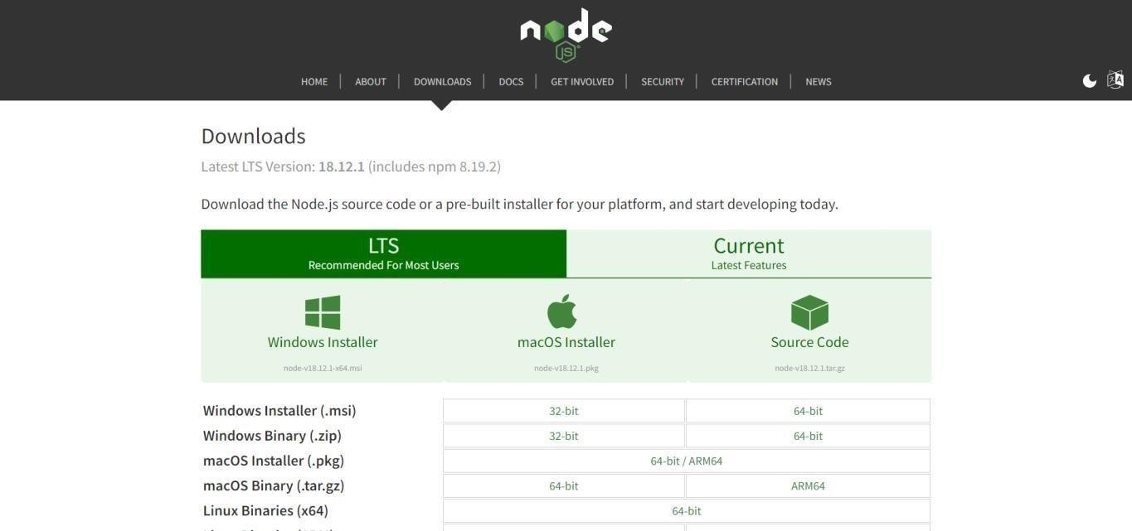

STEP2: Setup node.js and configure command prompt for error check.open node-red from the generated link.

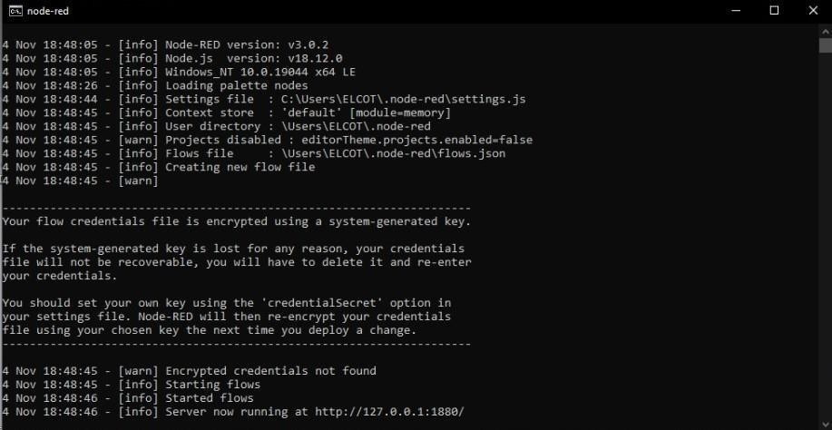

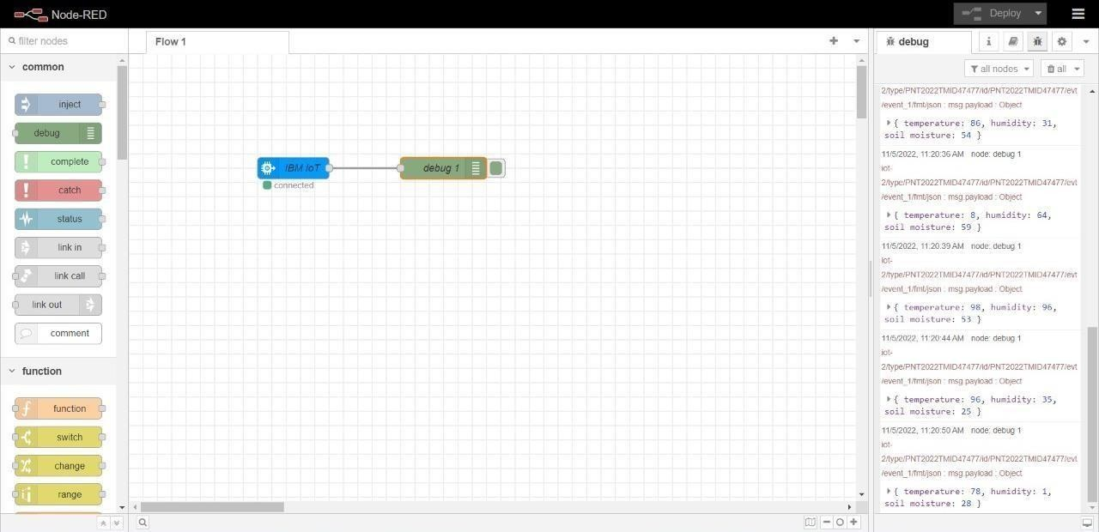STEP3: Connect IBM IOT in and Debug 1 and Deploy.

STEP4: Edit gauge node (Here the gauge nodes are named as Temperature, Humidity and Soil moisture).

